**How Stuff Works**

**Camera**

A camera is an [optical](https://en.wikipedia.org/wiki/Optics) instrument for recording or capturing [images](https://en.wikipedia.org/wiki/Image). The camera is a very common devices nowadays. All phones, laptops, tablets and even watches have it. It enables us to capture all of life's important moments. The invention of the camera was a turning point in human history. The functioning of the camera is very similar to the functioning of the [human eye](https://en.wikipedia.org/wiki/Human_eye). The first permanent [photograph](https://en.wikipedia.org/wiki/Photograph) of a camera image was made in 1826 by [Joseph Nicephorus Niepce](https://en.wikipedia.org/wiki/Joseph_Nic%C3%A9phore_Ni%C3%A9pce). The way a camera works is very similar to how the eye works.

A small hole is made on the outer side of the camera which allows light to enter inside the camera and it is formed on a device called the cmos. It is a very sensitive film on which the image is formed. Between the hole which allows the light to enter and the cmos is a mirror which deflects the light away when not needed. As soon as we press the button on the camera to take a picture, the mirror switches for a fraction of a second and lets the light hit the cmos which stores the image.

There are many things in a camera which we can change, such as the aperture, ISO, depth, zoom, shutter speed etc. These are all changed by modifying different parts of the camera. The three pillars in photography are:

**ISO**: This is the measure of how sensitive the image is to light.

**Aperture**: Simply put, this is how blurred the non-focused part of the image is. This is measured by how big the hole, through which the light enters the camera is. A bigger hole means that the non-focused part is more blurred.

**Shutter Speed**: This is how much light from the scene is captured by the cmos. Basically, it is a measure of how long the mirror allows the image to captured by the cmos. This usually lasts for 1/10000 th of a second to 1 second. The longer the exposure, the brighter the image is.

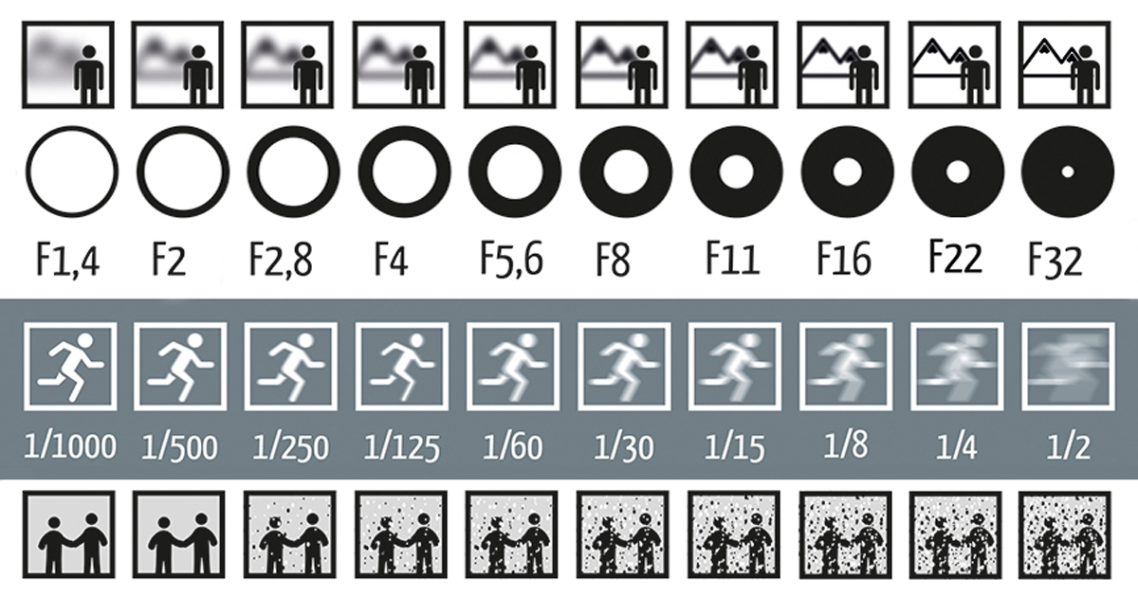

This image shows how the three factors affect an image

* The first factor is aperture, which is changed by how wide the hole is.
* The second factor is shutter speed, which is changed by how quickly the mirror exposes the image.
* The third factor is the ISO or white balance which shows how much noise is visible in the picture.

There are many types of cameras in the market available. These allow us to get the best type of picture for the best type of setting and frame.

The **Instax** is a camera which produces polaroid’s. These are images which when captured, aren’t formed on a cmos but on a special film which is then printed out. These are popular for parties and outings.

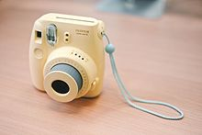

The **DSLRs** are very popular cameras. These are more professional and allow the user to control all the things mentioned above. These are used by professionals but are also very expensive.

